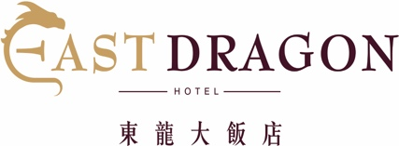
Legal Guardian Consent Form / 監護人同意書
I, _______________________, confirm I am the legal guardian of _______________________ (Passport Number _______________________), and hereby provide my consent and permission for his/her unsupervised travel arrangements at EAST DRAGON HOTEL in Taipei, Taiwan as per the hotel’s age policy for registered guests under the age of 20-years-old, between the dates of:________/________/________ (D/M/Y) to________/________/________(D/M/Y)
Name of legal guardian: _________ (Last name) _________(Frist name) Relationship:__________________ Tel number:___________________ E-mail:________________________
Signature: ____________________Approval date:___________________. Pease provide a photocopy of legal guardian’s personal ID or Passport

本人 _______________________ 身為 _______________________(旅客姓名) _______________________ (旅客護照號碼) 之家長或法定監護人，在此同意未滿 20 歲之受 監護人未由家長或監護人陪同入住台灣台北之 EAST DRAGON HOTEL 東龍大飯店，住宿期間自 ___________年______月______日入住至 ________年______月______日中午退房。住宿期間同 意遵東龍大飯店之相關作業規定，特簽此同意書，以茲證明。
監護人姓名:_______________
關係: _________________
連絡電話:__________________ 電子郵件:________________________
同意人簽名: _____________________日期: __________________. 請提供同意人證件影本 (身分證件或護照)

10842 台北市萬華區漢口街二段23號
No. 23, Section 2, Hankou St, Wanhua District, Taipei 10842, Taiwan Tel: +886-2-2311-6969 Fax: +886-2-2311-6967 www.east-dragon.com.tw

